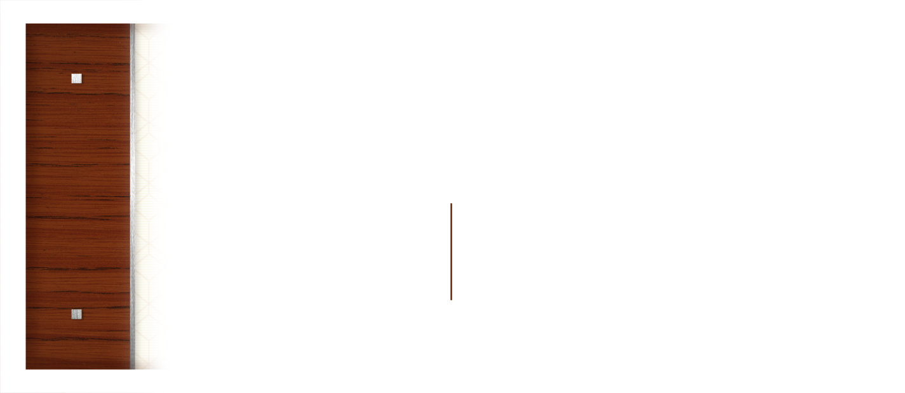
Insert Logo or Company name here
555 Street Address
City, State 55555

Company Name
Recipient’s Name
555 Street Address
City, State 55555

