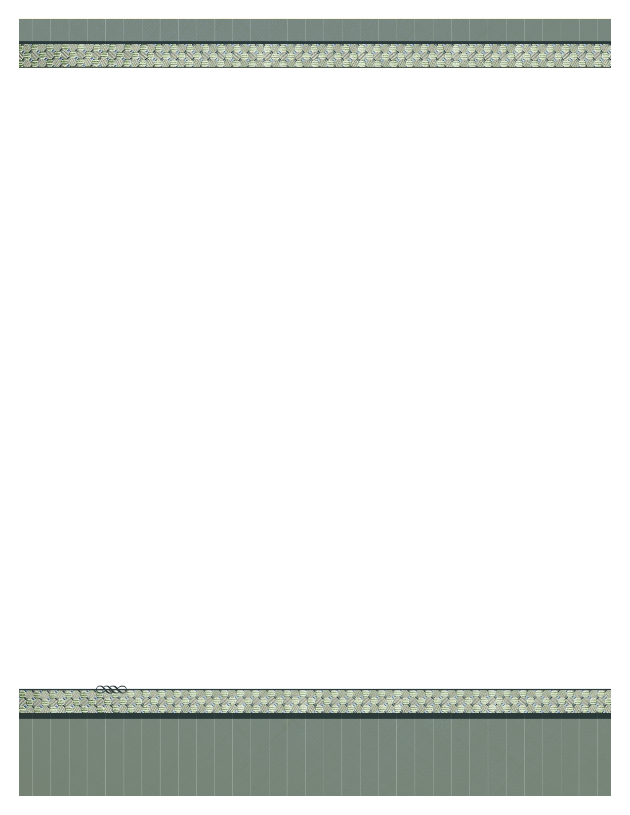
2012 Street address suite 310
City and, STATE 97555
555.555.5555 office • 555.555.5555 fax
www.your-url-goes-here.com

Insert Your Name Here
Place logo
or logotype here,
otherwise
delete this.
Begin your letter here.

