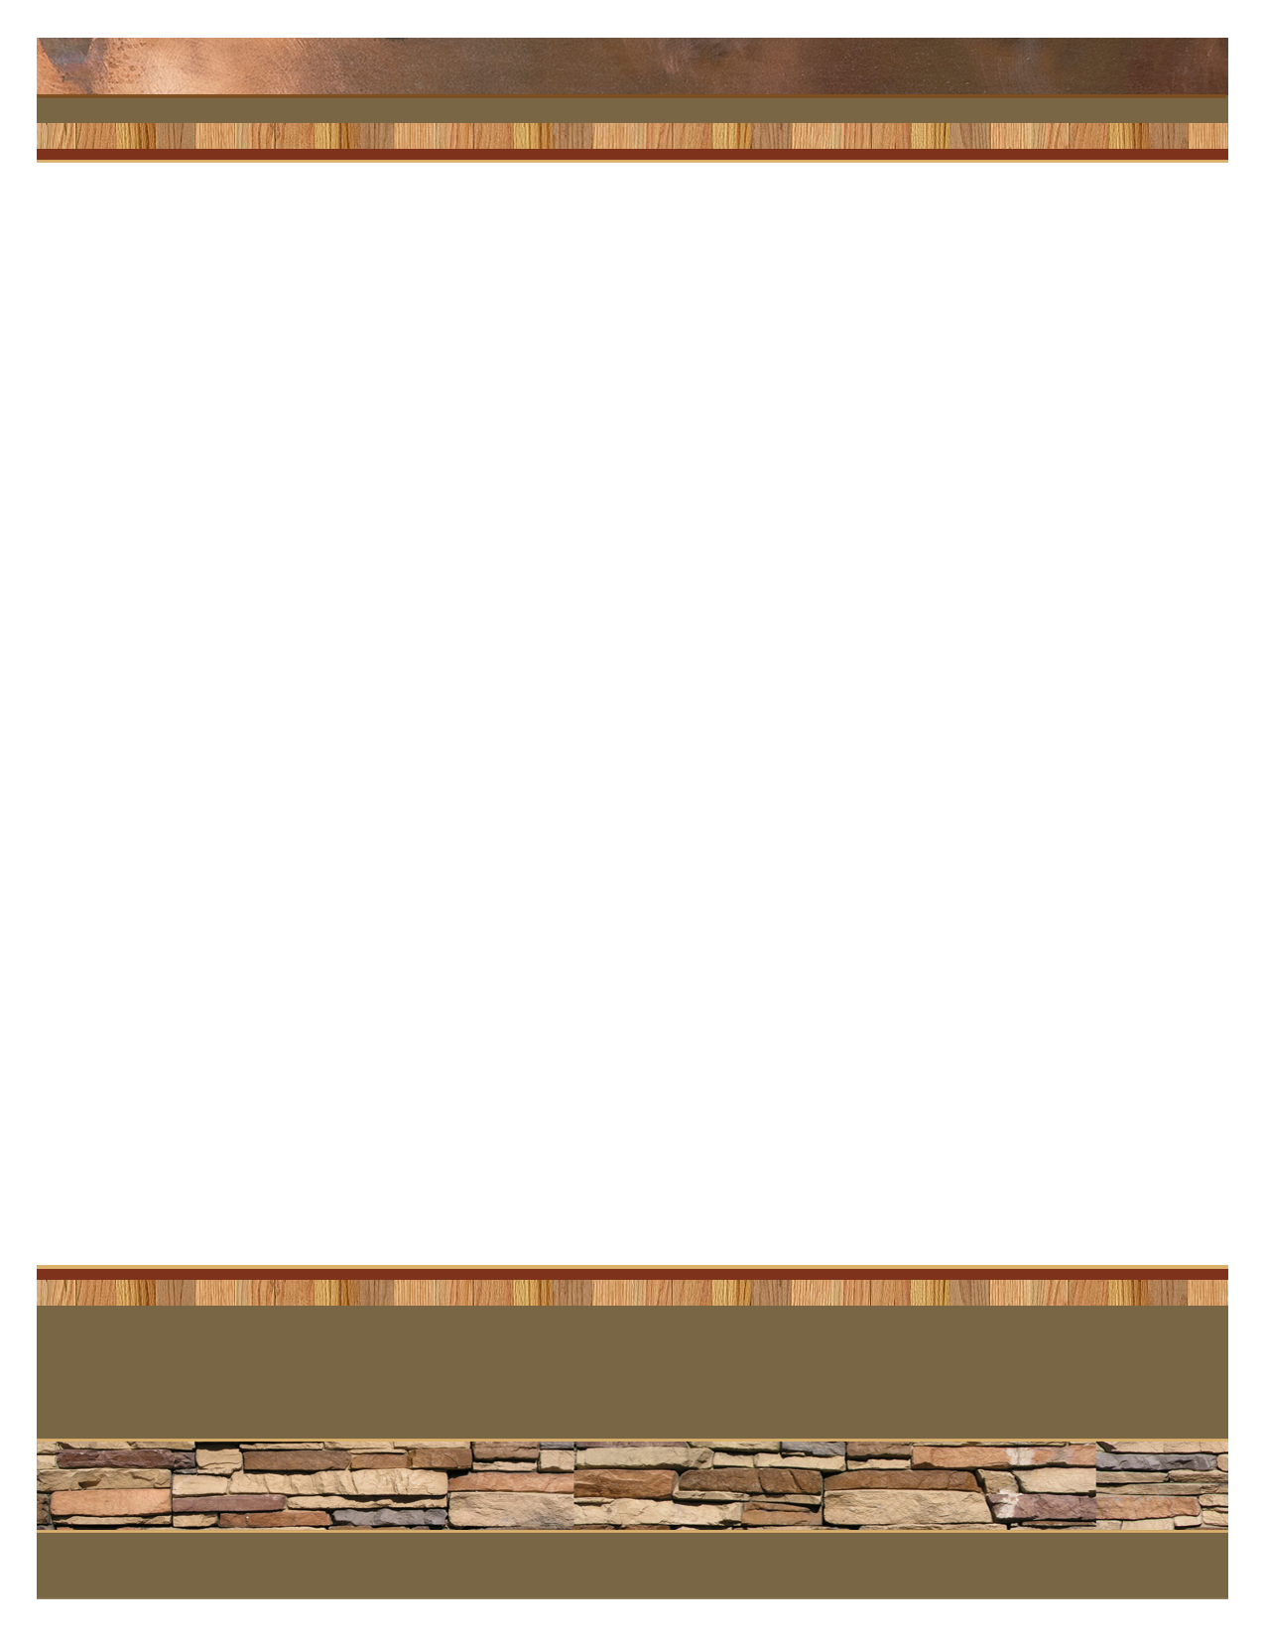
company name
555 Street Address
City, ST 55555

ph 555.555.5555 | fx 555.555.5555 | webaddress.com

Logo Goes Here.
Otherwise Delete.

Logo Goes Here.
Otherwise Delete.

Begin letter here.

