Our Family Newsletter

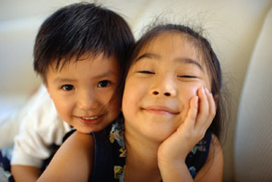
Special events in our family’s life

• Add a highlight from your family’s life

• Add a highlight from your family’s life

• Add a highlight from your family’s life

Caption describing picture or graphic.

Happy holidays from our family to yours!

“To catch the reader’s attention, place an interesting sentence or quote from the story here.”

The purpose of a holiday newsletter is to keep friends and family updated on the events in your family’s life and share holiday greetings across the miles. The holidays are a good time to tell about your experiences from the past year, and express warm wishes for the year to come.
When you send a holiday newsletter, you can let each member of the family write their own articles or stories. You can also include family portraits, or photographs from family vacations. Think about what you would tell your family and friends if you could see them.



How to get started

Writing a family newsletter can also be a fun activity to do together as a family. You can make everyone feel included and special as you take stock of the events in your life together.
First, sit down and talk about the most important things that have happened in the past year. Think about who will be reading your family newsletter. What would your friends or distant family members most like to hear about?
After you list the things you want to write about, organize your list into categories, like Introduction, Dad’s News, Mom’s News, Kids’ News, Special Messages, and Final Thoughts. If your children are old enough, consider asking them to write their own sections.

Caption describing picture or graphic.

Christmas 2004 ● Volume 1, Issue 1 ● Your Family’s Name ● (242) 555-0193

Working with linked text boxes

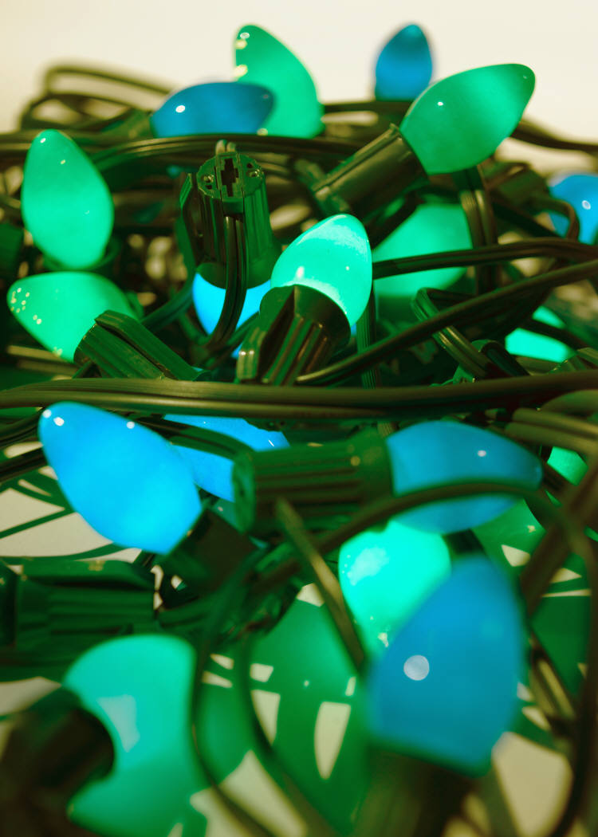

The text boxes in this newsletter are linked, so text from one column flows into the other column and you can easily include more than one story on a page.
When you are working with linked text boxes, you should turn on the Text Box toolbar. To do this, on the View menu, point to Toolbars, and then click Text Box.
When you start writing your story, we recommend that you do most of your writing and editing before you copy the text into the empty linked text boxes. To move among linked text boxes in a story, select a text box that is part of a story. On the Text Box toolbar, click Next Text Box or Previous Text Box.
To copy or move linked text boxes, select the first text box in the story. Hold down SHIFT and select each additional text box you want to copy or move. On the Edit menu, click Copy or Cut. Click where you want to copy or move the text boxes. On the Edit menu, click Paste.
You can also break a link between any two linked text boxes in a story. To do this, select the text box. On the Text Box toolbar, click Break Forward Link.

Caption describing picture or graphic.

Adding pictures to your newsletter



Pictures of your family trips, special events, and every day life will bring your newsletter stories to life. Once you have chosen a picture, place it close to the story. Be sure to place the caption of the image near the image.
If you want to use clip art in your newsletter, you can find thousands of clip art images on Microsoft Office Online that you can download and insert into your newsletter.
To change the pictures in this newsletter to your own, click the image you want to change. On the Insert menu, click Picture, and then click Clip Art or From File. Locate the image you want and double-click it. The new image will be inserted into the existing text box for easy positioning.
Tip: Text boxes that contain images or text often do not have borders showing, so it may not be apparent that an item is placed within a text box.
To see the text boxes that contain the pictures in this template, click Options on the Tools menu, click the View tab, and then select the Text boundaries check box under Print and Web Layout options.

Caption describing picture or graphic.

Page 2
Christmas 2004 ● Volume 1, Issue 1 ● Your Family’s Name ● (242) 555-0193

A special message from our family

Our Family
Address line 1
Address line 2
City, ST ZIP Code
Phone:
(242) 555-0167
Fax:
(242) 555-0168

E-Mail:
someone@example.com
Web Site:
www.widgets.msn.com

Our kids’ favorite
Christmas joke:

What do you call a person who is afraid of Santa Claus?

Claustrophobic!

On the back of your family’s newsletter, you may want to add a simple greeting, poem, or an example of your children’s artwork. This is the first part of the newsletter that your loved ones will see, so make sure that it is festive and eye-catching.
You can add your own artwork to the back of a family newsletter by scanning in a drawing or a photograph.

Season’s greetings!
A great way to add content to this newsletter is to include a calendar of upcoming events or a special memory that your family shares. You can also transcribe the words of a song or a poem onto the back of your newsletter to set the tone for the rest of your message.
With a little creativity and imagination, creating a holiday newsletter can be a great way to say “Season’s Greetings!”

A favorite family phrase or slogan can go here.

Our Family’s Name
Address line 1
Address line 2
City, ST ZIP Code
Friend’s Name
Street Address
City, State Zip Code

